Supplementary Table 1: Doses of insulin glargine and insulin glulisine – Safety population (N = 206)

Insulin glargine |  |  |  | Insulin glulisine
Missing data |  | Mean (SD) | Median (range) | Mean (SD) | Median (range)
Daily dose (U)
at first administration | 1 | 29.0 (13.5) | 28.0 (6.0; 86.0) | 22.7 (13.6) | 20.0 (3.0; 108.0)
at week 2 | 7 | 29.4 (13.7) | 28.0 (0.0; 86.0) | 23.8 (13.8) | 21.0 (0.0; 108.0)
at week 4 | 9 | 30.1 (13.7) | 26.0 (6.0; 86.0) | 25.4 (14.2) | 23.0 (4.0; 108.0)
at week 8 | 11 | 30.3 (13.9) | 26.0 (0.0; 86.0) | 26.3 (14.9) | 24.0 (0.0; 108.0)
at week 12 | 15 | 29.6 (12.8) | 26.0 (8.0; 86.0) | 27.9 (15.9) | 24.0 (3.0; 110.0)
at week 24 | 12 | 30.5 (13.6) | 27.5 (0.0; 90.0) | 28.7 (17.5) | 24.0 (0.0; 110.0)
Daily dose (U/kg)
at first administration | 2 | 0.4 (0.2) | 0.4 (0.1; 1.1) | 0.3 (0.2) | 0.3 (0.0; 1.1)
at week 12 | 16 | 0.4 (0.2) | 0.4 (0.1; 1.1) | 0.4 (0.2) | 0.4 (0.0; 1.5)
at week 24 | 12 | 0.4 (0.2) | 0.4 (0.0; 1.2) | 0.4 (0.2) | 0.4 (0.0; 1.6)

Supplementary Figure 1: Change in HbA1c from baseline to week 12 and week 24- PP
population

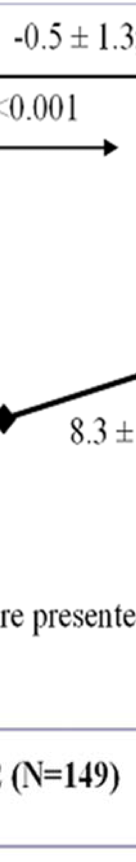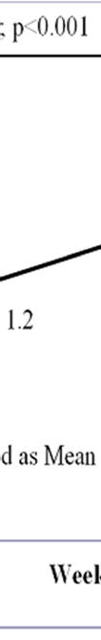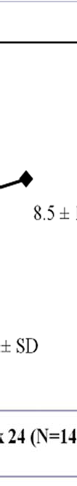

Supplementary Figure 2: Change in FBG from baseline to week 12 and week 24- PP population

